**FULL ADDER USING ONLY NAND GATES**

AIM:

To design and implement the full adder using Logisim simulator.

PROCEDURE:

1) Pick and place the necessary gates.

2) Insert 3 inputs into the canvas.

3) Connect the inputs to the XOR gate, AND gate and OR gate.

4) Insert 2 outputs into the canvas.

5) Make the connections using the connecting wires.

6) Verify the truth table.

TRUTH TABLE:

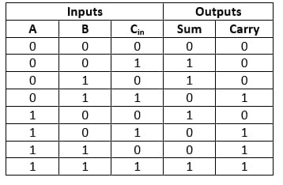

Sum=(A ⊕ B) ⊕ Cin

Carry=A.B + (A ⊕ B)

OUTPUT

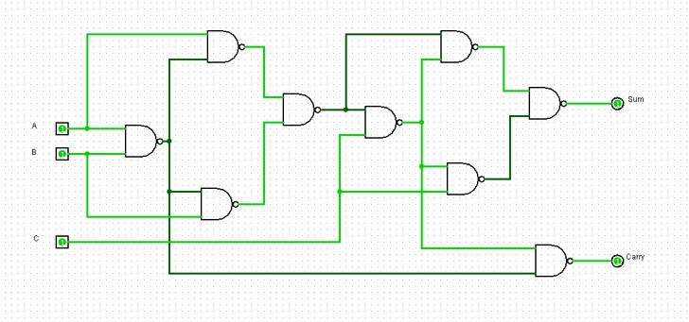

RESULT: Thus full adder has been designed and implemented successfully using logisim simulator